(d)

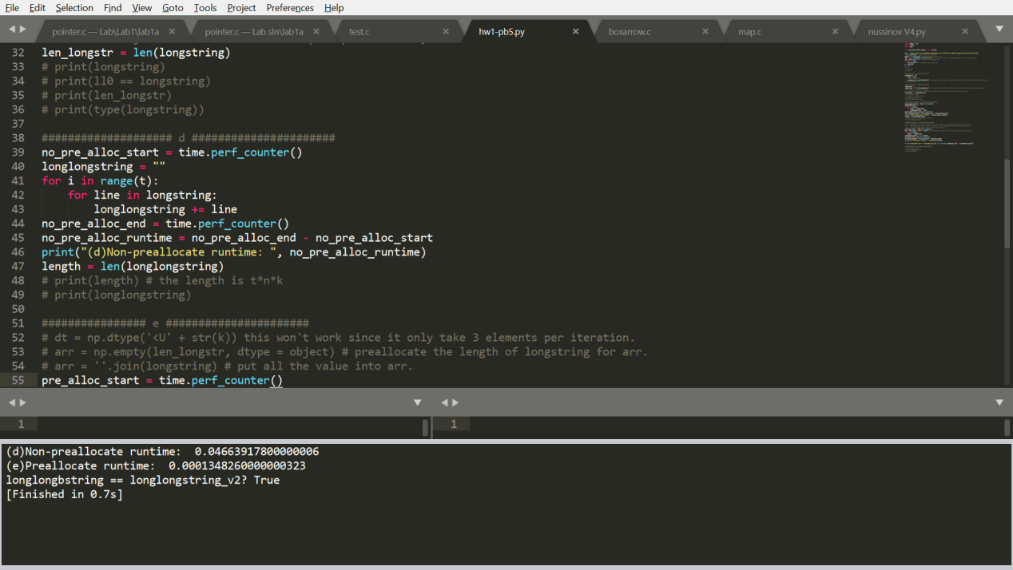

This is a nested for loop, which will take O(t\*n) times. Also, without preallocation of the size of list, when we read a new string and want to put the value inside the list. This will force the memory to reallocate for every iteration, meaning that we need another O(n) time to allocate the memory. And the total run time will be bounded by ${O(n}^{2})$

(e)

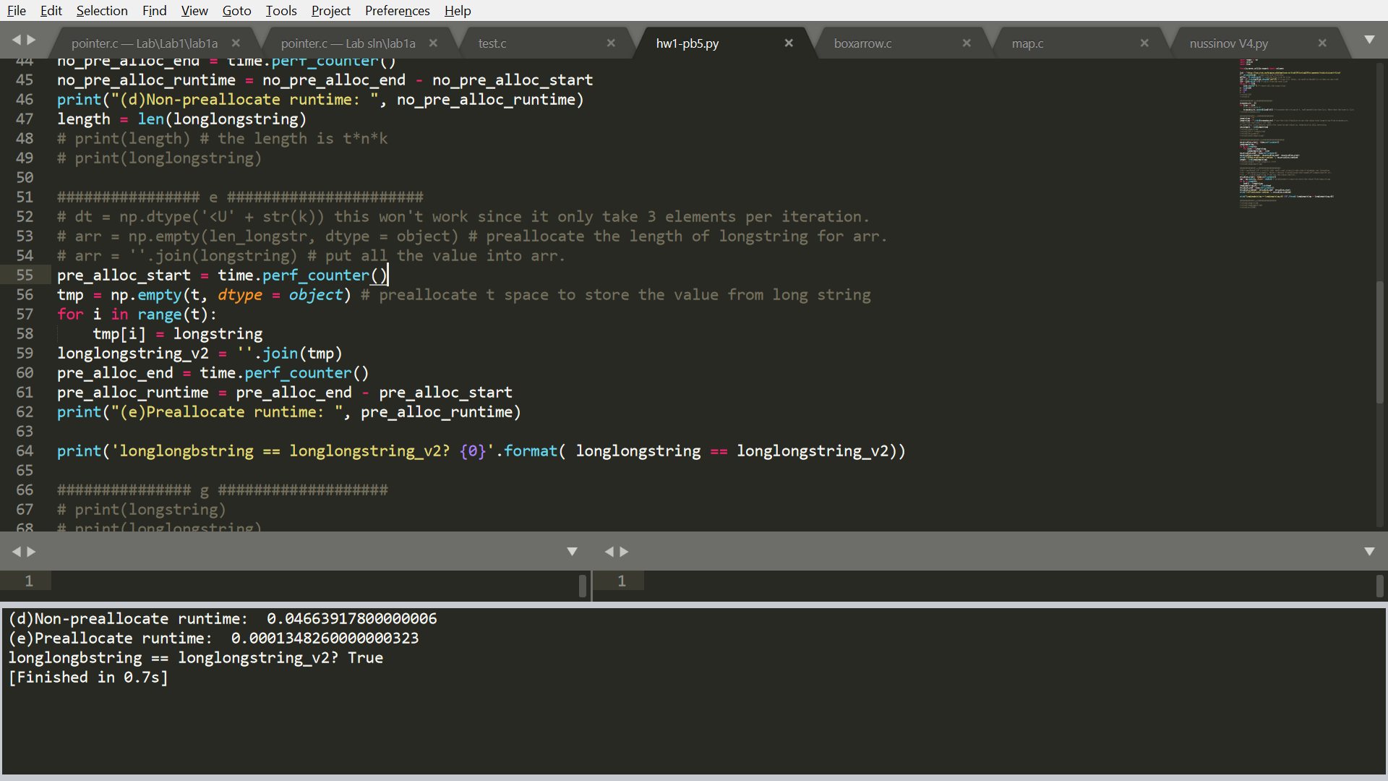

In this case, since we have already knew the length of the list. We can use numpy.empty to create an empty array, meaning that we have already assigned a memory space for the value to store. Therefore, whenever we have a new value, we only need O(1) to allocate the value into the array. Therefore, I only need to allocate t time space for the longstring to form the longlongstring. This will create a exactly array of the previous one. The total run time of this implementation will be O(n) since I only have to run through the list for a first time.

(f)



Clearly, we can see that the runtime is much faster when I preallocate it.